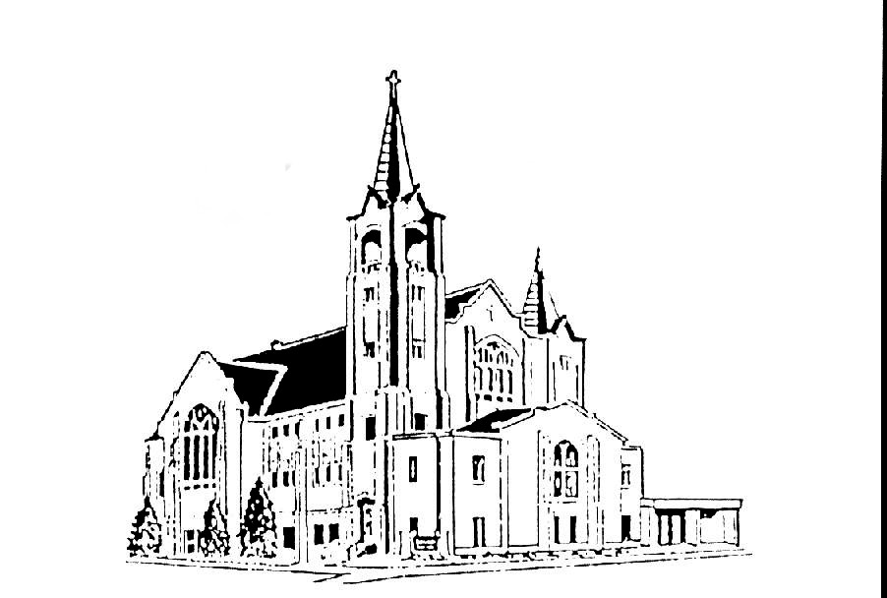 | Salem Lutheran Church  401 S. Lake St. Lake Mills IA 50450  Welcome to the House of the Lord  Midweek Lenten Service  March 9, 2022 – 7:00pm

TURNING TOWARD GOD’S ABUNDANCE: a lenten service of word and prayer

Lent is a season of repentance, turning to God and asking for God’s goodness to wipe away our sins and show us how to live anew. Lent also turns us toward Easter and the abundant life God will offer through the Three Days. This Lenten midweek service turns us toward God’s abundance by focusing on five divine attributes drawn from the gospel texts for Lent (year C): faithfulness, mercy, compassion, forgiveness, and love. Each service is designed for sustained reflection on the gospel in the context of contemplative prayer, readings, silence, and song.

WEEK ONE: FAITHFULNESS

THE TEMPTATION OF CHRIST

Greeting
The love of God poured into our hearts, the saving grace of Jesus Christ,
and the abundant life of the Holy Spirit be with you all.
And also with you.

Opening Prayer
O God, rich in mercy, full of kindness, out of your great love, you raise us up from sin and death and make us alive together with Christ. Write your word upon our hearts and restore in us the image of your love that, by your Spirit, our way of life may become the way of Christ, through whom we pray.
Amen.

Silence
The beginning and end of our time of silence will be marked by the chiming of a prayer bowl

Opening Song Bless Now, O God, the Journey ELW #326

Reading: “The Things That Count” by Ella Wheeler Wilcox
Now, dear, it isn’t the bold things,
Great deeds of valour and might,
That count the most in the summing up of life at the end of the day.
But it is the doing of old things,
Small acts that are just and right;
And doing them over and over again, no matter what others say;
In smiling at fate, when you want to cry, and in keeping at work when you want to play—
Dear, those are the things that count.

And, dear, it isn’t the new ways
Where the wonder-seekers crowd
That lead us into the land of content, or help us to find our own.
But it is keeping to true ways,
Though the music is not so loud,
And there may be many a shadowed spot where we journey along alone;
In flinging a prayer at the face of fear, and in changing into a song a groan—
Dear, these are the things that count.

My dear, it isn’t the loud part
Of creeds that are pleasing to God,
Not the chant of a prayer, or the hum of a hymn, or a jubilant shout or song.
But it is the beautiful proud part
Of walking with feet faith-shod;
And in loving, loving, loving through all, no matter how things go wrong;
In trusting ever, though dark the day, and in keeping your hope when the way seems long—
Dear, these are the things that count.

This poem is in the public domain. Published in Poem-a-Day on June 3, 2018, by the Academy of American Poets.

Silence
The beginning and end of our time of silence will be marked by the chiming of a prayer bowl

Sung response On My Heart Imprint Your Image ELW #811

Gospel: Luke 4:1-13 The Temptation of Jesus
¹Jesus, full of the Holy Spirit, returned from the Jordan and was led by the Spirit in the wilderness, ²where for forty days he was tempted by the devil. He ate nothing at all during those days, and when they were over, he was famished. ³The devil said to him, "If you are the Son of God, command this stone to become a loaf of bread." ⁴Jesus answered him, "It is written, 'One does not live by bread alone.'"
⁵Then the devil led him up and showed him in an instant all the kingdoms of the world. ⁶And the devil said to him, "To you I will give their glory and all this authority; for it has been given over to me, and I give it to anyone I please. ⁷If you, then, will worship me, it will all be yours." ⁸Jesus answered him, "It is written,
'Worship the Lord your God,
and serve only him.'"
⁹Then the devil took him to Jerusalem, and placed him on the pinnacle of the temple, saying to him, "If you are the Son of God, throw yourself down from here, ¹⁰for it is written,
'He will command his angels concerning you,
to protect you,'
¹¹and
'On their hands they will bear you up,
so that you will not dash your foot against a stone.'"

¹²Jesus answered him, "It is said, 'Do not put the Lord your God to the test.'" ¹³When the devil had finished every test, he departed from him until an opportune time.

Time of prayer and reflection:
The leader invites the community into prayer
In Christ Jesus we meet the God who knows our weakness and bears the wounds of the world. Therefore, let us be bold as we pray, trusting that God draws near to those in any kind of need.

You may wish to close your eyes and ask God to guide your sight and reflection. You are invited to light additional candles as you meditate and pray for guidance, for those who have gathered, for others who are unable to be with us, for healing, inspiration, for the needs of the community, our nation, the world.

Time of conversation: What do you suppose Jesus thought about or did in his 40 days of fasting, prayer and temptation in the wilderness? In the temptation of Christ where do you see and experience God’s abundance?

Concluding prayer:
God of all compassion, gather our prayers in your mercy and grant to us what you know we need, that we may walk in the life and the peace of your Spirit, through Jesus Christ, our hope and our salvation.
Amen.

Lord’s prayer
Our Father, who art in heaven, hallowed be thy name, thy kingdom come, thy will be done, on earth as it is in heaven. Give us this day our daily bread; and forgive us our trespasses, as we forgive those who trespass against us; and lead us no into temptation, but deliver us from evil. For thine is the kingdom, and the power, and the glory, forever and ever.
Amen.

Concluding song On Eagle’s Wings ELW #787

Blessing
Christ Jesus dwell in our hearts through faith,
as we are being rooted and grounded in love,
strengthened by the Spirit,
and filled with all the fullness of God.
Amen.

A greeting of peace may be shared by all.

From sundaysandseasons.com. Copyright © 2021 Augsburg Fortress. All rights reserved. Reprinted by permission under Augsburg Fortress Liturgies Annual License #SAS020622.
New Revised Standard Version Bible, Copyright © 1989, Division of Christian Education of the National Council of the Churches of Christ in the United States of America. Used by permission. All rights reserved. Revised Common Lectionary, Copyright © 1992 Consultation on Common Texts, admin Augsburg Fortress. Used by permission

