WEEKLY ANNOUNCEMENTS

SALEM LUTHERAN CHURCH
October 16 – 22

Kyrie eleison: Persistence in Prayer
Two characters step out of scripture today to teach us about persistence in prayer. One is named. Jacob is the devious brother who tricked his twin, Esau, out of his birthright and their father’s blessing, and Jacob was himself duped on his wedding night by his father-in-law, Laban. The other character, unnamed, is a widow acquainted with grief, one among many marginalized and vulnerable people, but a woman who dares to stand her ground in her quest for justice. On the banks of the river Jabbok, Jacob wrestles with the angel and limps away with a blessing and a new identity. The unnamed widow repeatedly appeals for justice and finally is vindicated. Many have known persistent prayer as a kind of wrestling with God. Many have pleaded with God for justice and mercy. Today God’s grace and mercy is known in the blessing of baptismal remembrance and our identity as beloved children of God.

THIS WEEKS TEXTS  Genesis 32:22-31  Psalm 121  2 Timothy 3:14--4:5  Luke 18:1-8 | NEXT WEEKS TEXTS  Jeremiah 14:7-10, 19-22  Psalm 84:1-7  2 Timothy 4:6-8, 16-18  Luke 18:9-14
Each week we will lift up five church families/members in prayer. We ask that you also remember them in your daily prayers. THIS WEEK WE WILL PRAY FOR: James and Raymond Nielson, Diane Nordskog, Marietta Noris, Wayne, Judy and Monty Nyguard, Heidi Obermeyer and Tanner, Spencer and Kayler Jensen

This week the following members will be celebrating their birthdays and we would like to wish them a HAPPY BIRTHDAY!!! Please call the office if you have an upcoming birthday, to ensure we have it in our records. 641.592.1771
15-Denise White  15-Jenna Eidness  16-Ella Rogstad  17-John Ekstrand | 17-Austin Henderson  18-Bradley Helgeson  18-Adelyn Brackey  19-Kayler Jensen | 21-David Grothe  21-Brady Schmidt  22-Rhonda Huston  22-Holly Hagen

-WEEKLY GIVING-
LAST SUNDAY: 10/9/22 $ 2,681
YEAR-TO-DATE: 10/12/22 $ 164,420
LAST YEAR: as of 10/12/21 $ 179,297
DIFFERENCE YEAR TO DATE: $ - 14,877

Noisy Offering is being collected September 25th - October 23rd for the Good Samaritan Ministry here at Salem. This ministry has helped individuals with rent/groceries/fuel, among other critical needs. This ministry follows Jesus' teachings to love one another. Thank you for your contributions!

Knitters & Crocheters needed! We have been gifted with a lot of baby yarn and would love to have help making sweaters and caps for the baby kits. Yarn and patterns can be found in the Narthex (or use a pattern of your own). If you have any questions, call Sue Langerud 641.568.3620

WELCA will meet on Thursday, Oct. 20th at 2:00pm in the Fellowship Hall. Everyone is welcome to attend! Kim Katutu, daughter of Mary Mehus from Northwood, will be the guest speaker, sharing about her mission work in Africa.

Hand Bell Practice will be on Wednesdays at 7:00pm in the Choir Room. Anyone interested can still come and join the group (6th grade and above).
October 23rd: A special congregational meeting will be held in the sanctuary on Sunday, October 23rd, after the 9:00am worship service. This meeting is being called to vote on a proposed capitol project to tuckpoint/repair the bell tower and other specific areas of our church building. Additional building repairs will be discussed as potential continuation of this project.

Trunk or Treat: The Youth & Education Board is hosting Trunk or Treat on Sunday, October 30th; 4:00pm-5:00pm in the alleyway behind Salem. Everyone is welcome! To host a trunk, sign up on the Faith Formation table across from the chapel, or call the office. We need more hosts, please consider hosting a trunk! There will be warm drinks and snacks served too! Fun for all ages!

Baked Goods: The Youth & Education Board is looking for donations of cookies, bars or snack mix that can be served at the Trunk or Treat event on October 30th. Please sign up in the Narthex or call the office if you would be willing to help. Then drop them off in the lounge by 1pm on October 30th. Thank you!

Fall Lutheran World Relief Shipment went to Albert Lea on Saturday, Oct. 8th. We sent 108 quilts, 2 blankets, 147 school kits and 37 baby care kites. Thanks to John, Wayne and Steve for loading them and to Steve for transporting them. The extra school supplies went to the Lake Mills School. Also, 16 quilts went to the Mason City Salvation Army. Thank you for all the contributions given so that we could have a great shipment. We could use any sheets, pillow cases, good hand towels and bath towels. Tiers, sewers, knitters and crocheters are always needed and appreciated too. -Mission Quilters

Prayer Pen Pals: The Board of Life & Growth is seeking Prayer Pen Pals for 1st graders. This includes sending a letter to a 1st grader and keeping them in your prayers. If you would be willing to do this, please contact Sue Langerud. 641.568.3620

Volunteers Need: If you are willing to usher, acolyte, read or sing in the liturgical choir, sign up in the Narthex or call the office. If you would like to learn how to help with sound, monitors or live stream, call the office. Thank you!!!
Congregational Birthday Party: The Board of Life and Growth invites everyone to a Congregational Birthday Party on October 16th in the Fellowship Hall, right after worship. This is to honor all of our members birthdays! Grab a cupcake and punch and sit at your birth month table. There will be birthday games and prizes too! Everyone is welcome! It will be fun for all ages!!

Fall Dinner: West Prairie Lutheran Church, 40041-150th Ave, Leland IA, has sent an invitation to their Fall Dinner on Sunday, October 23rd; 10:30am-1:30pm. Adults-$10, Children 10 & under-$5. Menu: BBQ Meatballs, Cheesy Potatoes, Southern Green Beans, Dinner Roll, Cookie/Bar and Beverage. There are 3 dining options: church fellowship hall, carryout or delivery* (For delivery, call 641-567-3733, leave your name and number, you will be contacted for delivery details. *Leland, Forest City, Thompson, Buffalo Center, Lake Mills)

Lutefisk Supper: Emmons Lutheran Church has sent an invitation to their 62nd Lutefisk Supper on Tuesday, November 1st; serving at 11am, 12:30pm, 5:30pm & 7pm. Adults-$22 in advance (no refunds) Children 10 & under $8. Menu: Lutefisk, Meatballs & Gravy, Mashed Potatoes, Corn, Sweet Pepper Coleslaw, Cranberry Relish, Lefse, Pastries. Tickets available at MBT Bank in Lake Mills.

Scandinavian Bazaar: Trinity Lutheran Church, 213 N. Pennsylvania Ave, Mason City IA, has sent and invitation to their Scandinavian Bazaar on Thursday, November 3rd; 8am-2pm. Coffee Shop featuring Norwegian sandwiches, lefse, pastries, rolls, pies and more will be open 8am-10:30am. Luncheon (serving 2 shifts) seating at 11am and 12:00pm. Menu: Scandinavian Meatball dinner with pie-$9 Take out available. All meal tickets need to be purchases in advance, Call 641-423-0536 to purchase tickets in advance. They will also have a Scandinavian Boutique featuring unique holiday and everyday gifts, a Gift Gallery with beautifully handcrafted one of a kind items, a Candy & Bake Shop with Norwegian pastries, candies, breads, cookies, bars and more and a Book Nook with puzzles and gently used hardcover and paperback books for all ages.

Live Stream Sponsorship: Call the office to reserve your special date. The cost is $40 per Sunday. 2022 Dates available: Oct. 30, Nov. 6, Nov. 13
Pastoral Visits: If you or someone you know would like a visit from Pastor Joel, please call the office to make an appointment. 641.592.1771

Pastor Joel Guttormson
Mon: Off, but on-call (Fall Theological Conference)
Tues: (Fall Theological Conference)
Wed: Noon-8:00pm (10am Adult Bible Study)
Thurs: Noon-8pm (1pm Mills Harbour Bible Study, 2pm WELCA, 4pm Life & Growth Meeting)
Fri: 8am-Noon, 1pm-5pm (UNI Lock-In)
Sat: 10am-Noon (UNI Lock-In, service prep)
Sun: 8am-Noon (9am Worship Service)

Salem Office: 641.592.1771
Mon-Tues: 10am-5pm
Wed: 10am-12pm
Thurs-Fri: 10am-5pm
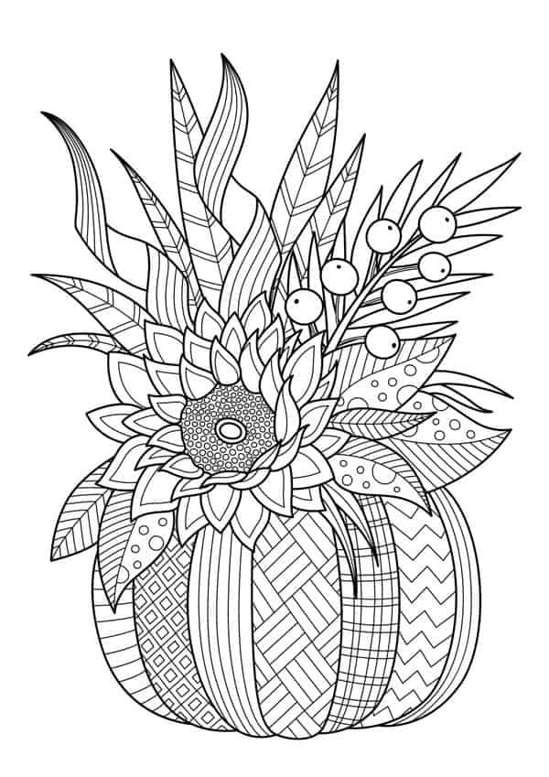
Fall Family Traditions
Traditions build family bonds, create memories and are just plain fun! Here’s a list of great family traditions. Don’t try to do them all, just adopt a few that speak deeply to you. Think about the sights, sounds and scents of the season. The joy of traditions is that you want to do them year after year.

_______1. Visit an Orchard and pick apples
_______2. Get lost in a corn maze
_______3. Jump in a leaf pile
_______4. Have a pumpkin Spice flavored everything day
_______5. Carve epic pumpkins
_______6. Make homemade soup or bread
_______7. Start a family gratitude journal
_______8. Take a fall family walk or car ride
_______9. Gather around a bonfire
_______10. Visit a state park
_______11. Donate to your local food pantry
_______12. Take fall family photos
_______13. Listen to the rain or play in puddles
_______14. Take fall treats to a neighbor
_______15. Make leaf rubbings
_______16. Have a fall picnic
_______17. Family game night
_______18. Eat Halloween cereal
_______19. Do a random act of kindness
_______20. Flannel or cozy sweater day
_______21. Volunteer as a family
_______22. Do a puzzle as a family
_______23. Have an apple everything day
_______24. Host a costume dinner
_______25. Try a new apple recipe
_______26. Mail a fall care package
_______27. Help a neighbor rake leaves
_______28. Fall Camping or star gazing
_______29. Make a spooky playlist
_______30. Create a photo scavenger hunt
_______31. Take a hayride
_______32. Attend a fall festival
_______33. Take a full moon walk
_______34. Family Bike Ride
_______35. Roast pumpkin seeds
_______36. Make something with pears
_______37. Walk through an old cemetery
_______38. Scary movie marathon
_______39. Visit a farmers Market
_______40. Make your own Halloween costumes
_______41. Write a letter to your oldest family member
_______42. Decorate your porch for fall
_______43. Friendsgiving
_______44. Make caramel apples
_______45. Thankful Thursdays
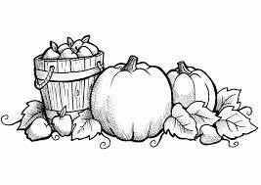
All are invited downstairs to the fellowship hall after worship for the Congregational Birthday Party.

SUNDAY 10/16
9:00am Worship Service-Sanctuary
10:00am Congregational Birthday Party-Fellowship Hall

MONDAY 10/17
2:00pm-4:00pm Clothes Closet is OPEN
(To schedule a different time, call 641.592.5085)
2:30pm-5:00pm Lake Mills Food Shelf is OPEN (101 S. Mill St.)
6:30pm Quilt Club-Fellowship Hall

WEDNESDAY 10/19
10:00am Adult Bible Study-Fellowship Hall
3:15pm Brownies-Room 2
7:00pm Handbell Choir Practice-Choir Room

THURSDAY 10/20
1:00pm Mills Harbour Bible Study
2:00pm WELCA-Speaker Kim Katutu-Fellowship Hall
3:15pm Juniors-Room 2
4:00pm Life & Growth Board Meeting-Fellowship Hall

FRIDAY 10/21
Confirmation UNI Lock-In

SUNDAY 10/23
9:00am Worship Service-Sanctuary
10:00am Fellowship-Fellowship Hall
10:00am Faith Formation-Chapel
10:00am Confirmation-Youth Room

