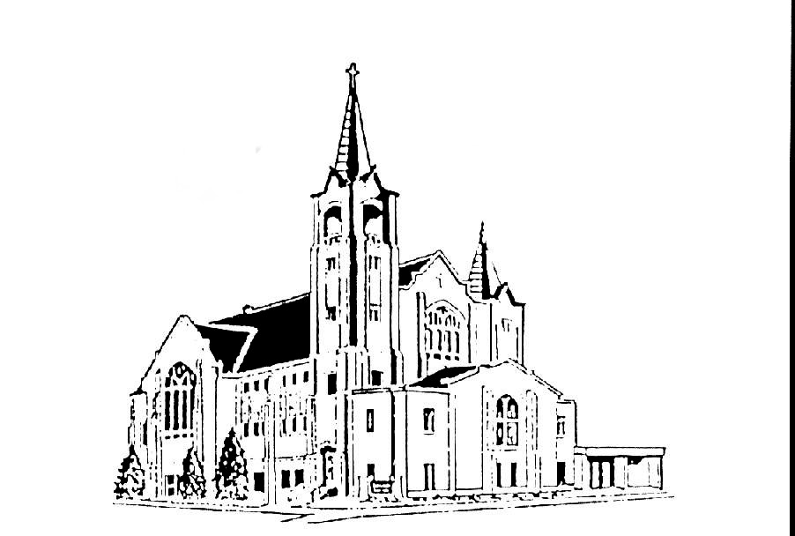 | Salem Lutheran Church  401 S. Lake St. Lake Mills IA 50450  Welcome to the House of the Lord  WEEK FOUR: FORGIVENESS  March 30, 2022 – 7:00pm

TURNING TOWARD GOD’S ABUNDANCE: a lenten service of word and prayer
Lent is a season of repentance, turning to God and asking for God’s goodness to wipe away our sins and show us how to live anew. Lent also turns us toward Easter and the abundant life God will offer through the Three Days. This Lenten midweek service turns us toward God’s abundance by focusing on five divine attributes drawn from the gospel texts for Lent (year C): faithfulness, mercy, compassion, forgiveness, and love. Each service is designed for sustained reflection on the gospel in the context of contemplative prayer, readings, silence, and song.

THE PRODIGAL SON

Greeting
The love of God poured into our hearts, the saving grace of Jesus Christ,
and the abundant life of the Holy Spirit be with you all.
And also with you.

Opening Prayer
O God, rich in mercy, full of kindness, out of your great love, you raise us up from sin and death and make us alive together with Christ. Write your word upon our hearts and restore in us the image of your love that, by your Spirit, our way of life may become the way of Christ, through whom we pray.
Amen.

Silence
The beginning and end of our time of silence will be marked by the chiming of a prayer bowl

Opening Song Our Father, We Have Wandered ELW #606

Reading: “A Short Testament” by Anne Porter

Whatever harm I may have done
In all my life in all your wide creation, creation
If I cannot repair it
I beg you to repair it,

And then there are all the wounded
The poor the deaf the lonely and the old
Whom I have roughly dismissed
As if I were not one of them.
Where I have wronged them by it
And cannot make amends

I ask you
To comfort them to overflowing,

And where there are lives I may have withered around me,
Or lives of strangers far or near
That I've destroyed in blind complicity,
And if I cannot find them
Or have no way to serve them,

Remember them. I beg you to remember them

When winter is over
And all your unimaginable promises
Burst into song on death's bare branches.

From Living Things by Anne Porter, published by Zoland Books, an imprint of Steerforth Press of Hanover, New Hampshire. Copyright © 2006 by Anne Porter. All rights reserved.

Silence
The beginning and end of our time of silence will be marked by the chiming of a prayer bowl

Sung response In All Our Grief ELW #615

Gospel: Luke 15:1-3, 11b-32 The Prodigal Son
¹Now all the tax collectors and sinners were coming near to listen to him. ²And the Pharisees and the scribes were grumbling and saying, "This fellow welcomes sinners and eats with them."
³So he told them this parable: ¹¹Then Jesus said, "There was a man who had two sons. ¹²The younger of them said to his father, 'Father, give me the share of the property that will belong to me.' So he divided his property between them. ¹³A few days later the younger son gathered all he had and traveled to a distant country, and there he squandered his property in dissolute living. ¹⁴When he had spent everything, a severe famine took place throughout that country, and he began to be in need. ¹⁵So he went and hired himself out to one of the citizens of that country, who sent him to his fields to feed the pigs. ¹⁶He would gladly have filled himself with the pods that the pigs were eating; and no one gave him anything. ¹⁷But when he came to himself he said, 'How many of my father's hired hands have bread enough and to spare, but here I am dying of hunger! ¹⁸I will get up and go to my father, and I will say to him, "Father, I have sinned against heaven and before you; ¹⁹I am no longer worthy to be called your son; treat me like one of your hired hands." ' ²⁰So he set off and went to his father. But while he was still far off, his father saw him and was filled with compassion; he ran and put his arms around him and kissed him. ²¹Then the son said to him, 'Father, I have sinned against heaven and before you; I am no longer worthy to be called your son.' ²²But the father said to his slaves, 'Quickly, bring out a robe — the best one — and put it on him; put a ring on his finger and sandals on his feet. ²³And get the fatted calf and kill it, and let us eat and celebrate; ²⁴for this son of mine was dead and is alive again; he was lost and is found!' And they began to celebrate.
²⁵Now his elder son was in the field; and when he came and approached the house, he heard music and dancing. ²⁶He called one of the slaves and asked what was going on. ²⁷He replied, 'Your brother has come, and your father has killed the fatted calf, because he has got him back safe and sound.' ²⁸Then he became angry and refused to go in. His father came out and began to plead with him. ²⁹But he answered his father, 'Listen! For all these years I have been working like a slave for you, and I have never disobeyed your command; yet you have never given me even a young goat so that I might celebrate with my friends. ³⁰But when this son of yours came back, who has devoured your property with prostitutes, you killed the fatted calf for him!' ³¹Then the father said to him, 'Son, you are always with me, and all that is mine is yours. ³²But we had to celebrate and rejoice, because this brother of yours was dead and has come to life; he was lost and has been found.'"

Time of prayer and reflection:
The leader invites the community into prayer.
In Christ Jesus we meet the God who knows our weakness and bears the wounds of the world. Therefore, let us be bold as we pray, trusting that God draws near to those in any kind of need.

You may wish to close your eyes and ask God to guide your sight and reflection. You are invited to light additional candles as you meditate and pray for guidance, for those who have gathered, for others who are unable to be with us, for healing, inspiration, for the needs of the community, our nation, the world.

Time of conversation: Many people have their own prodigal (child) stories. They may be stories of your own wayward acts. They may be stories of loved ones who have gone astray. This gospel has historically been called “the parable of the prodigal son” but recently it has been thought as “the parable of the prodigal son(s)” The parable Jesus told was in the context of tax collectors and sinners coming near to listen to him, and Pharisees and scribes who were grumbling. Who is more willing to receive the grace and mercy the father so willingly and abundantly offers. In the parable of the prodigal (ones) where to you see and experience God’s abundance?

Laying on of hands as an act of giving and receiving God’s forgiveness:
Laying both hands on the head of another each person is invited to address another in turn.

In obedience to the command of our Lord Jesus Christ, I forgive you all your sins.
The person may respond Amen.

Concluding prayer:
God of all compassion, gather our prayers in your mercy and grant to us what you know we need, that we may walk in the life and the peace of your Spirit, through Jesus Christ, our hope and our salvation.
Amen.

Lord’s prayer
Our Father, who art in heaven, hallowed be thy name, thy kingdom come, thy will be done, on earth as it is in heaven. Give us this day our daily bread; and forgive us our trespasses, as we forgive those who trespass against us; and lead us not into temptation, but deliver us from evil. For thine is the kingdom, and the power, and the glory, forever and ever.
Amen.

Concluding song Go, My Children, with My Blessing ELW #543
Blessing
Christ Jesus dwell in our hearts through faith,
as we are being rooted and grounded in love,
strengthened by the Spirit,
and filled with all the fullness of God.
Amen.

A greeting of peace may be shared by all.

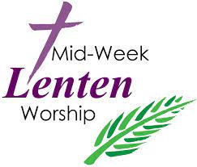

From sundaysandseasons.com. Copyright © 2021 Augsburg Fortress. All rights reserved. Reprinted by permission under Augsburg Fortress Liturgies Annual License #SAS020622.
New Revised Standard Version Bible, Copyright © 1989, Division of Christian Education of the National Council of the Churches of Christ in the United States of America. Used by permission. All rights reserved. Revised Common Lectionary, Copyright © 1992 Consultation on Common Texts, admin Augsburg Fortress. Used by permission

