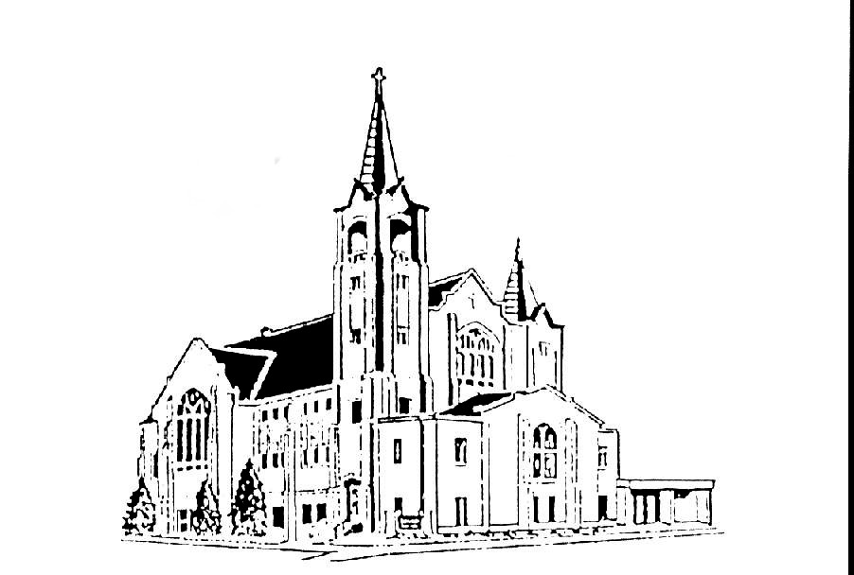 | Salem Lutheran Church  401 S. Lake St. Lake Mills IA 50450  Welcome to the House of the Lord  Ash Wednesday  Turning toward God’s Abundance  March 2, 2022 – 7:00pm

OUR MISSION: We are God forgiven and mission driven.

OUR VISION: To be that Lake Mills place where belonging, healing, growing, serving and believing are open to all, regardless of background, experience or aptitude. Central to this is that we are a forgiving, mission-driven community, which means we all want to have an impact, shaped by the love of Christ to serve all others.

Preaching: Pastor Joel Guttormson
Organist: Ruth Sheldon
Reader: Sondra Nelson
Acolytes: Lyle Thomson
Ushers: Lyle & Orloue Thomson

Salem Contact Information:
Pastor Joel Guttormson: 641.596.0535  joelguttormson@gmail.com  Shannon Bruhns, Council President: 641.592.5978 / 641.590.1532  shelby@wctatel.net | Ruth Sheldon, Organist: 641.592.0184  Barb Kinseth, Custodian  Marci Adeogun, Office Admin: 641.590.1182  Salem Office: 641.592.1771  salem@wctatel.net
INTRODUCTION

On Ash Wednesday we begin our forty-day journey toward Easter with a day of fasting and repentance. Marking our foreheads with dust, we acknowledge that we die and return to the earth. At the same time, the dust traces the life-giving cross indelibly marked on our foreheads at baptism. While we journey through Lent to return to God, we have already been reconciled to God through Christ. We humbly pray for God to make our hearts clean while we rejoice that “now is the day of salvation.” Returning to our baptismal call, we more intentionally bear the fruits of mercy and justice in the world.

GATHERING
PRELUDE
ANNOUNCEMENTS

CONFESSION AND FORGIVENESS
All may make the sign of the cross, the sign marked at baptism, as the presiding minister begins.

In the name of God, who makes a way in the wilderness, walks with us,
and guides us in our pilgrimage.
Amen.

Silence is kept for reflection.
Holy One,
we confess that we have wandered far from you:
we have not trusted your promises,
we have ignored your prophets in our own day,
we have squandered our inheritance of grace,
we have failed to recognize you in our midst.
Have mercy on us!
Forgive us and turn us again to you.
Teach us to follow in your ways,
assure us again of your love,
and help us to love our neighbor.
Amen.
Beloved in Christ, the Word draws near to you, and all who call out to God shall be saved. In Jesus, God comes to you again and again and gathers you under wings of love. In ☩ Jesus’ name, your sins are forgiven. God journeys with you and teaches you how to live in love.
Amen.

OPENING HYMN Just As I Am, without One Plea ELW #592

PRAYER OF THE DAY
Gracious God, out of your love and mercy you breathed into dust the breath of life, creating us to serve you and our neighbors. Call forth our prayers and acts of kindness, and strengthen us to face our mortality with confidence in the mercy of your Son, Jesus Christ, our Savior and Lord, who lives and reigns with you and the Holy Spirit, one God, now and forever.
Amen.

IMPOSITION OF ASHES
All who desire are invited to come forward to receive ashes on their foreheads. Pastors will mark the forehead of each person with a cross of ashes, saying:

Remember you are dust and to dust you shall return

HYMN DURING IMPOSITION Savior, When in Dust to You ELW #601

WORD

FIRST READING Joel 2:1-2, 12-17
¹Blow the trumpet in Zion; sound the alarm on my holy mountain! Let all the inhabitants of the land tremble, for the day of the Lord is coming, it is near—
²a day of darkness and gloom, a day of clouds and thick darkness! Like blackness spread upon the mountains a great and powerful army comes; their like has never been from of old, nor will be again after them in ages to come.
¹²Yet even now, says the Lord, return to me with all your heart, with fasting, with weeping, and with mourning; ¹³rend your hearts and not your clothing. Return to the Lord, your God, for he is gracious and merciful, slow to anger, and abounding in steadfast love, and relents from punishing. ¹⁴Who knows whether he will not turn and relent, and leave a blessing behind him, a grain offering and a drink offering for the Lord, your God?

¹⁵Blow the trumpet in Zion; sanctify a fast; call a solemn assembly; ¹⁶gather the people. Sanctify the congregation; assemble the aged; gather the children, even infants at the breast. Let the bridegroom leave his room, and the bride her canopy.
¹⁷Between the vestibule and the altar let the priests, the ministers of the Lord, weep. Let them say, “Spare your people, O Lord, and do not make your heritage a mockery, a byword among the nations. Why should it be said among the peoples,
‘Where is their God?’ ”

Word of God, word of life
Thanks be to God.

PSALM Psalm 51:1-17
The psalm will be spoken responsively beginning with the lector.
¹Have mercy on me, O God, according to your steadfast love; in your great
compassion blot out my offenses.
²Wash me through and through from my wickedness, and cleanse me from my sin.
³For I know my offenses, and my sin is ever before me.
⁴Against you only have I sinned and done what is evil in your sight; so you are justified when you speak and right in your judgment.
⁵Indeed, I was born steeped in wickedness, a sinner from my mother’s womb.
⁶Indeed, you delight in truth deep within me, and would have me know wisdom deep within.

⁷Remove my sins with hyssop, and I shall be clean; wash me, and I shall be
purer than snow.
⁸Let me hear joy and gladness; that the body you have broken may rejoice.

⁹Hide your face from my sins, and blot out all my wickedness.
¹⁰Create in me a clean heart, O God, and renew a right spirit within me.

¹¹Cast me not away from your presence, and take not your Holy Spirit from me.
¹²Restore to me the joy of your salvation and sustain me with your bountiful spirit.

¹³Let me teach your ways to offenders, and sinners shall be restored to you.
¹⁴Rescue me from bloodshed, O God of my salvation, and my tongue shall
sing of your righteousness.
¹⁵O Lord, open my lips, and my mouth shall proclaim your praise.
¹⁶For you take no delight in sacrifice, or I would give it. You are not pleased
with burnt offering.
¹⁷The sacrifice of God is a troubled spirit; a troubled and broken heart, O God,
you will not despise.
PSALM REFRAIN Create in Me a Clean Heart ELW #186

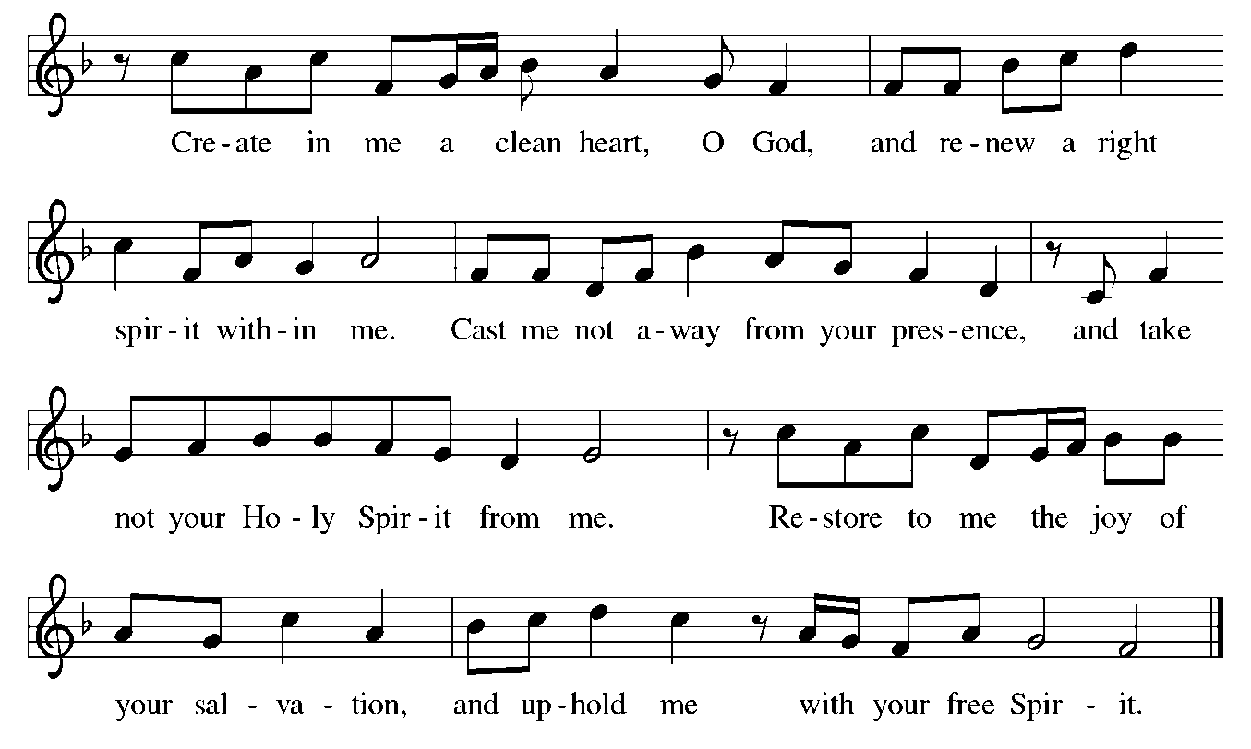

SECOND READING 2 Corinthians 5:20b-6:10
^{20b}We entreat you on behalf of Christ, be reconciled to God. ²¹For our sake he made him to be sin who knew no sin, so that in him we might become the righteousness of God.
^{6:1}As we work together with him, we urge you also not to accept the grace of God in vain. ²For he says,
“At an acceptable time I have listened to you,
and on a day of salvation I have helped you.”
See, now is the acceptable time; see, now is the day of salvation! ³We are putting no obstacle in anyone’s way, so that no fault may be found with our ministry, ⁴but as servants of God we have commended ourselves in every way: through great endurance, in afflictions, hardships, calamities, ⁵beatings, imprisonments, riots, labors, sleepless nights, hunger; ⁶by purity, knowledge, patience, kindness, holiness of spirit, genuine love, ⁷truthful speech, and the power of God; with the weapons of righteousness for the right hand and for the left; ⁸in honor and dishonor, in ill repute and good repute. We are treated as impostors, and yet are true; ⁹as unknown, and yet are well known; as dying, and see—we are alive; as punished, and yet not killed; ¹⁰as sorrowful, yet always rejoicing; as poor, yet making many rich; as having nothing, and yet possessing everything.

Word of God, word of life
Thanks be to God.

GOSPEL ACCLAMATION Return to the Lord, Your God ELW p.142
We stand for the hearing of the gospel.
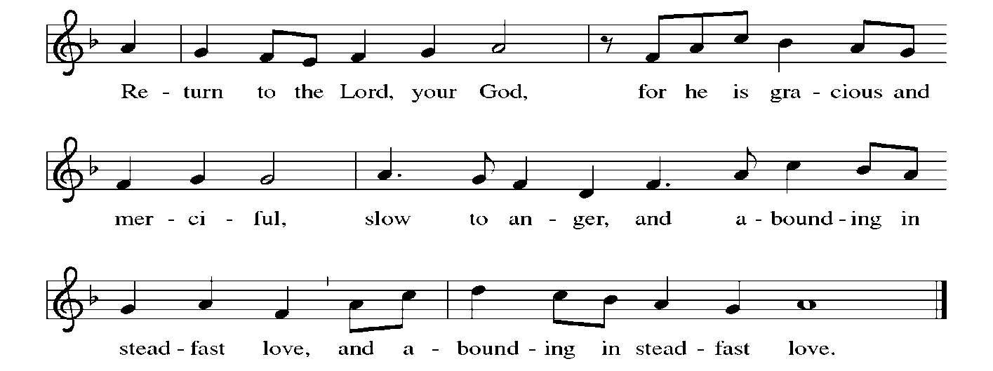

GOSPEL Matthew 6:1-6, 16-21
The holy gospel according to Matthew
Glory to you, O Lord.

[Jesus said to the disciples:] ¹“Beware of practicing your piety before others in order to be seen by them; for then you have no reward from your Father in heaven.
²“So whenever you give alms, do not sound a trumpet before you, as the hypocrites do in the synagogues and in the streets, so that they may be praised by others. Truly I tell you, they have received their reward. ³But when you give alms, do not let your left hand know what your right hand is doing, ⁴so that your alms may be done in secret; and your Father who sees in secret will reward you.
⁵“And whenever you pray, do not be like the hypocrites; for they love to stand and pray in the synagogues and at the street corners, so that they may be seen by others. Truly I tell you, they have received their reward. ⁶But whenever you pray, go into your room and shut the door and pray to your Father who is in secret; and your Father who sees in secret will reward you.
¹⁶“And whenever you fast, do not look dismal, like the hypocrites, for they disfigure their faces so as to show others that they are fasting. Truly I tell you, they have received their reward. ¹⁷But when you fast, put oil on your head and wash your face, ¹⁸so that your fasting may be seen not by others but by your Father who is in secret; and your Father who sees in secret will reward you.
¹⁹“Do not store up for yourselves treasures on earth, where moth and rust consume and where thieves break in and steal; ²⁰but store up for yourselves treasures in heaven, where neither moth nor rust consumes and where thieves do not break in and steal. ²¹For where your treasure is, there your heart will be also.”

The gospel of the Lord.
Praise to you, O Christ.

SERMON

SERMON HYMN Our Father, by Whose Name ELW #640

RESPONSE TO THE WORD

PRAYERS OF INTERCESSION
Drawn close to the heart of God, we offer these prayers for the church, the world, and all who are in need.
A brief silence.

Renew your church, O God. When we have drifted from our call to proclaim repentance and to guide your people toward justice, lead us back to you. Encourage believers who hold the church’s doors open to those who have felt excluded. Merciful God,
receive our prayer.

Renew your creation, O God. Transform parched places into watered gardens and preserve every creature that awaits the arrival of spring. Turn each of us from practices of environmental exploitation to become responsible stewards of all you have made. Merciful God,
receive our prayer.

Renew our civic life, O God. Teach those in authority to advocate for the liberation of all who are oppressed and grant them courage to make difficult decisions. Merciful God,
receive our prayer.

Renew our lives, O God. Spare your people from diseases of the body, mind, or spirit and send healing to those overcome by illness or grief. Restore to us the joy of your salvation. Merciful God,
receive our prayer.
Renew this congregation, O God. During these forty days of Lent, confirm our sense of mission and expand our imagination for ministry. Deepen our faith, increase our love, and draw us into your unfolding work of healing and restoration. Merciful God,
receive our prayer.

As we mark ashes on our foreheads, we give you praise, O God, for all the saints who died and yet are alive with you. Receive us with them into your eternal embrace. Merciful God,
receive our prayer.

The pastor concludes the prayers.
Accept the prayers we bring, O God, on behalf of a world in need, for the sake of Jesus Christ.
Amen.

OFFERING

MUSICAL OFFERING

OFFERING PRAYER
Extravagant God, you have blessed us with the fullness of creation. Now we gather at your feast where you offer us the food that satisfies. Take and use what we offer here, come among us, and feed us with the body and blood of Christ,
in whose name we pray.
Amen.

LORDS PRAYER
Our Father, who art in heaven, hallowed be thy name, thy kingdom come, thy will be done, on earth as it is in heaven. Give us this day our daily bread; and forgive us our trespasses, as we forgive those who trespass against us; and lead us not into temptation, but deliver us from evil. For thine is the kingdom, and the power, and the glory, forever and ever.
Amen.

BLESSING
You are children of God, anointed with the oil of gladness
and strengthened for the journey.
Almighty God, motherly, majestic, and mighty,
☩ bless you this day and always.
Amen.

SENDING HYMN Eternal Lord of Love, Behold Your Church ELW #321
DISMISSAL
Go in peace. Jesus meets you on the way.
Thanks be to God.

POSTLUDE
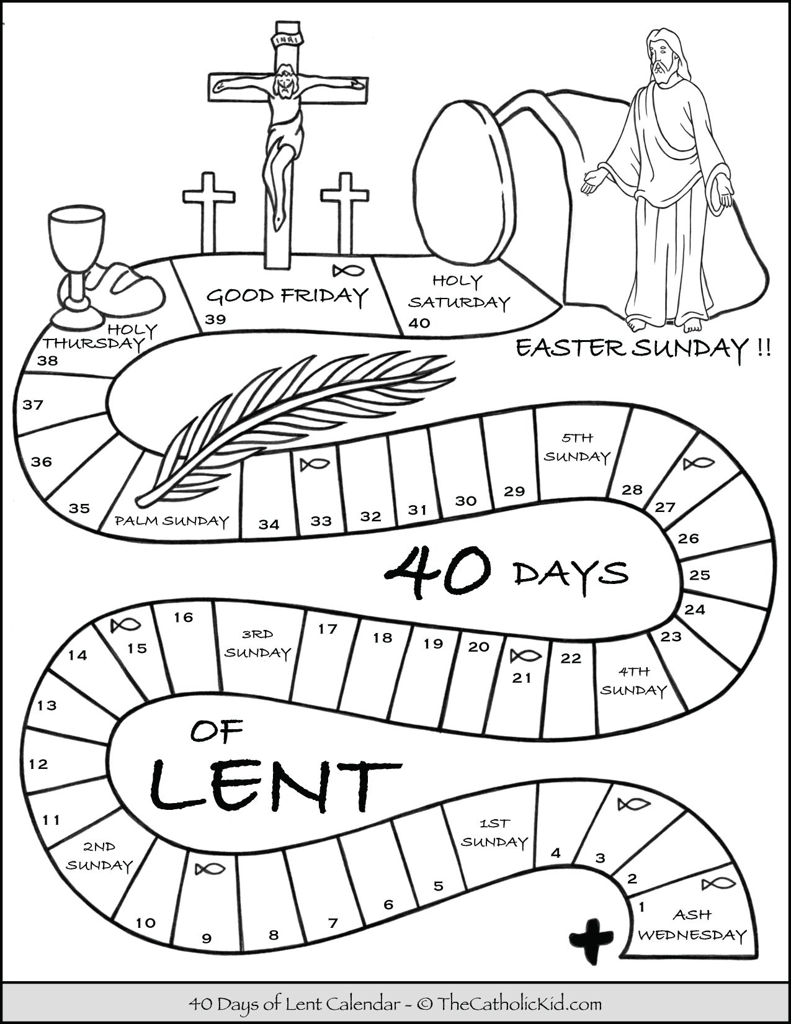

Copyright © 2020 Augsburg Fortress. All rights reserved. Reprinted by permission under Augsburg Fortress Liturgies Annual License #SAS020622.
New Revised Standard Version Bible, Copyright © 1989, Division of Christian Education of the National Council of the Churches of Christ in the United States of America. Used by permission. All rights reserved.
Revised Common Lectionary, Copyright © 1992 Consultation on Common Texts, admin Augsburg Fortress. Used by permission.

